Squeeze’s
Chris Difford and Glenn Tilbrook present
“The At Odds Couple” Tour
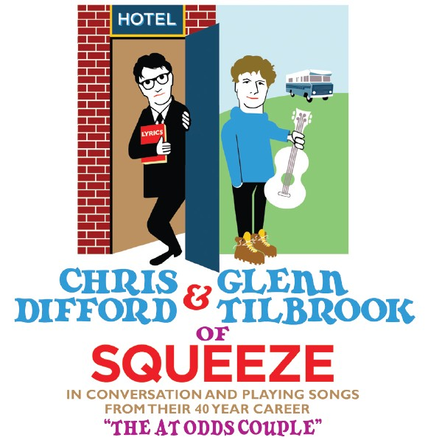
www.squeezeofficial.com

For the first time in almost 20 years, Squeeze’s Chris Difford and Glenn Tilbrook will be heading out on the road as a duo with ‘The At Odds Couple’ tour that will see them present their songs and story in a unique way. Beginning at Cambridge Corn Exchange on November 2nd, the 12 date tour will visit theatres around the UK in a show that will celebrate their enduring music and partnership.

“The At Odds Couple” Tour
Date | Venue
Sunday 2nd November | Cambridge Corn Exchange
Monday 3rd November | Northampton Derngate
Thursday 6th November | Reading Hexagon
Friday 7th November | Union Chapel, London
Saturday 8th November | Union Chapel, London
Monday 10th November | Guildford G Live
Tuesday 11th November | Birmingham Town Hall
Thursday 13th November | Newcastle Theatre
Friday 14th November | Edinburgh Queens Hall
Sunday 16th November | The Lowry, Salford
Monday 17th November | York Opera House
Tuesday 18th November | Union Chapel, London
Wednesday 19th November | Warwick Arts Centre

Buy online: Gigsandtours.com / 24hr cc hotline: 0844 811 0051

Chris Difford’s lyrics and Glenn Tilbrook’s music have prevailed through turbulent times over the past four decades, from the ever-changing musical landscape to their own internal reshuffles and an acrimonious break-up. ‘The At Odds Couple’ will see Glenn and Chris reflecting on their careers, as part of Squeeze and as solo artists, sharing not only the music but also giving an insight in to what makes the two of them tick as a partnership.

“There is a lot of history and myth to our relationship. There have been times when we’ve not gotten on and not communicated with each other but we are now at a place where we have a lot of respect for each other”, explains Chris. “No relationship is plain sailing, whether it be personal or work, but over the years we’ve come to understand our differences and similarities and learnt to co-exist alongside each other.”

“The last few years have been really interesting. We’ve talked more than ever and reflected on our relationship and it’s brought us to this point”, added Glenn.

In addition to performing a selection of hits, including ‘Up The Junction’ and ‘Cool For Cats’, Chris and Glenn will be dusting down some previously unrecorded songs that were written together back in the band’s infancy but never recorded, “there are a few corkers in there”, as well as playing tracks from their solo careers. The duo has also been working on new Squeeze material – set for release in 2015 - which will no doubt creep into the set list.

Since reforming in 2007, Squeeze have become a favourite on the festival circuit with appearances at V, Oxegen, T in the Park, Latitude and, to great acclaim, the seminal US Festival Coachella. In 2010 Squeeze’s contribution to music was noted with the site of their first gig being awarded a prestigious PRS For Music Heritage Plaque. It joined an ever-increasing list of Squeeze accolades alongside their Ivor Novello for Outstanding Contribution to British Music and their Nordoff-Robbins Icon Award, as well as the Mojo Magazine Icon Award.

2010 also saw the band embark on their biggest tour in over 10 years taking their ‘Spot The Difference’ show to over 20 venues around the UK. Ahead of the tour, Squeeze released the album ‘Spot The Difference’, a collection of 14 of their best-loved hits, re-recorded by the band to be as close to the original versions as possible (whilst challenging their fans to spot the difference!). Squeeze went back out on the road in 2012 with the direct-to-fan ‘Pop Up Shop’ tour concept with every show recorded live each evening and made available at the end of the night from the merchandise stand.

When they’ve not been touring and performing in Squeeze both Glenn and Chris have had successful solo careers. In Squeeze’s downtime Chris has broadened his musical horizons and recorded three solo albums; 2003’s ‘I Didn’t Get Where I Am’, 2007’s ‘The Last Temptation of Chris’ and 2010’s ‘Cashmere If You Can’. He has also worked on a number of other music projects including curating 2010’s ‘Songs In The Key of London’ concert at the Barbican. The show included former Squeeze bandmates Glenn Tilbrook and Jools Holland as well as Elvis Costello singing their favourite songs about London. He is bringing ‘Songs in the Key of London’ to Regents Park on June 1st with Sophie Ellis-Bextor, Paloma Faith, Suggs and Ed Harcourt, as a fundraiser for the Elton Johns Aids Foundation. Chris still manages to find time to co-manage The Strypes for Rocket Management.

Glenn recently released his third solo album ‘Happy Ending’ which garnered rave reviews and proved his musicality and sense of craft are more energised than ever. This album is a follow up to his critically acclaimed first outing as a solo artist 'The Incomplete Glenn Tilbrook' (2001) and 'Transatlantic Ping Pong' (2004). As well as his solo albums, Glenn has worked on a number of musical projects including 2009’s album 'Pandemonium Ensues' with his solo band The Fluffers and some prestigious guests in the shape of Johnny Depp and Vanessa Paradis. In 2011 he released ‘The Co-Operative’, a collaboration with blues legends Nine Below Zero, and recently he has been producing up and coming Australian band 'Millions'. Glenn also finds time to be involved with his friend Mike Peter's charity 'Love Hope Strength', with whom he has trekked to the top of Mt Fuji and Mt Kilimanjaro as well as to Base Camp on Mt Everest, helping to raise money for cancer units in deprived areas. He has also recently become involved with Bali based charity Inspirasia, with whom he will be travelling to Asia at the end of the year.

Difford’s ying to Tilbrook’s yang, Glenn’s chalk to Chris’s cheese, ‘The At Odds Couple’ will be in the spotlight and under the microscope like never before as these two talents of the music industry come together to present a unique two man show.

For more information contact info@republicmedia.net / 020 3213 0135

